**Course name : Computer**

**Course code: ECE001**

**Research article:**

**Computer Architecture**

**Student Name:**

**Arwa Mohamed Gad**

**Under observation of:**

**Dr.Ahmed Bayoumi**

**Dr.Shady Elmashad**

**Dr.Abdelhamid Attaby**

**Group: 2 Section:8**

*Research Application Brief:

This application is about computer architectures. I choosed this topic because we have already studied it so it will be easy to make a research about it. In this research I will mention the definition and history of computer architecture ,computer parts , computer subcategories and design goals in an application of html codes by using visual studio code.

*Research Application screenshots: the main page: contents list

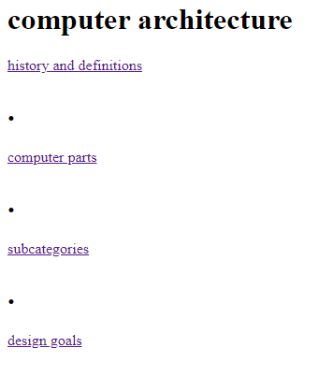

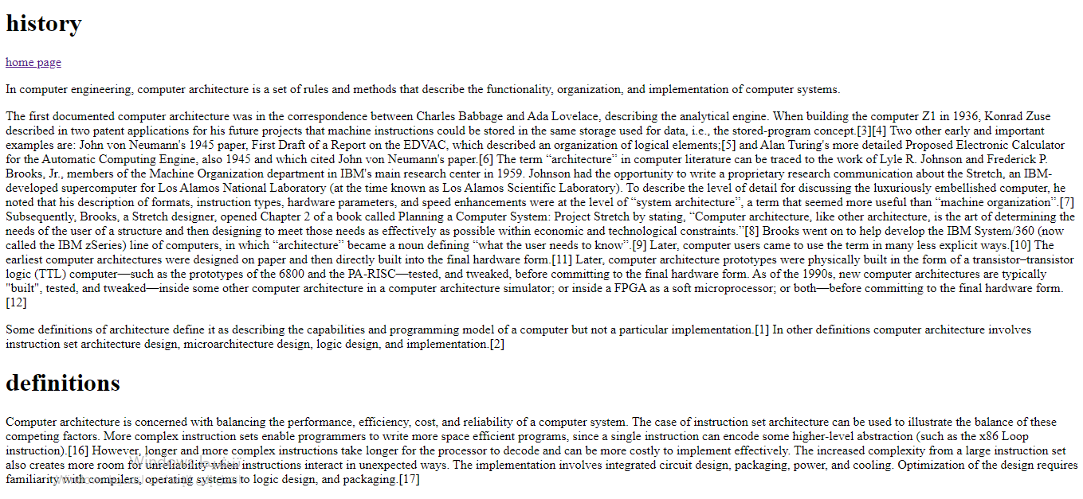 A linked web page :history and definitions

A linked web page contains images and tables:computer parts. 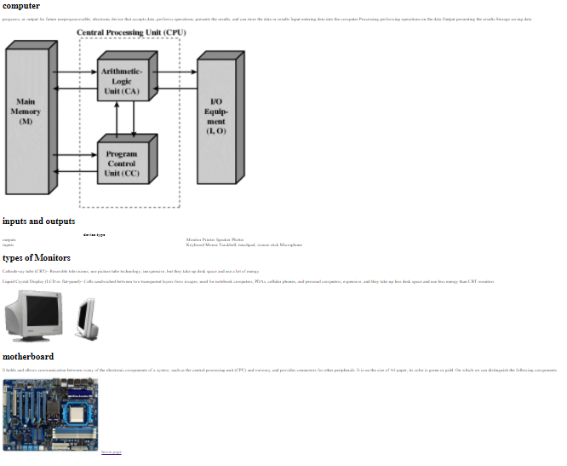

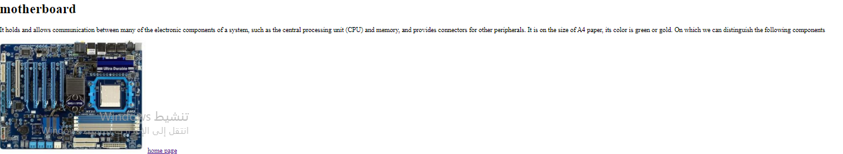

A linked web page : subcategories

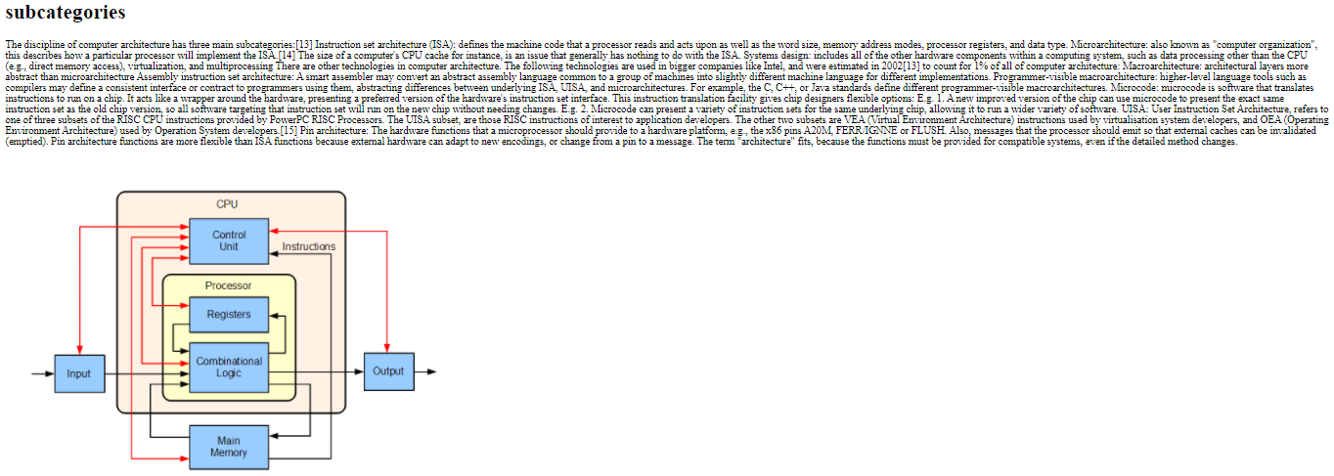

A linked web page : designs goals

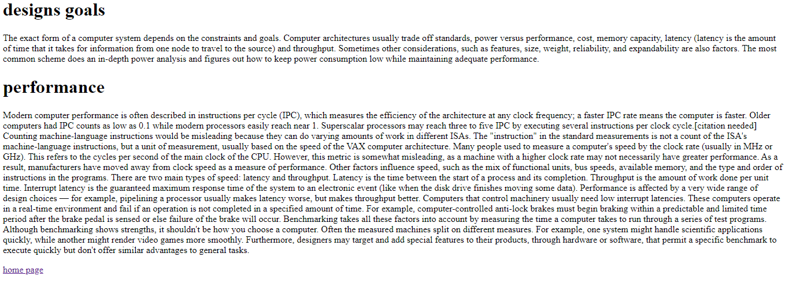

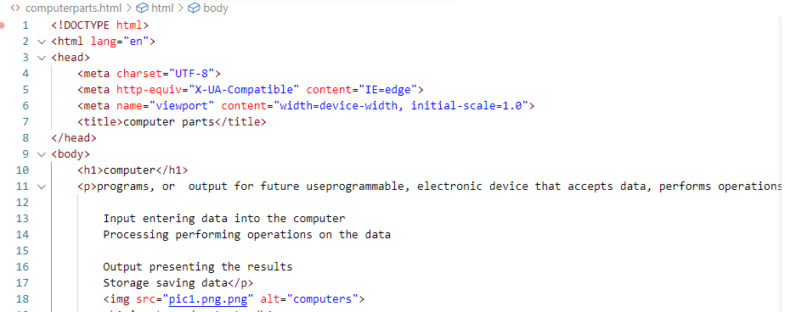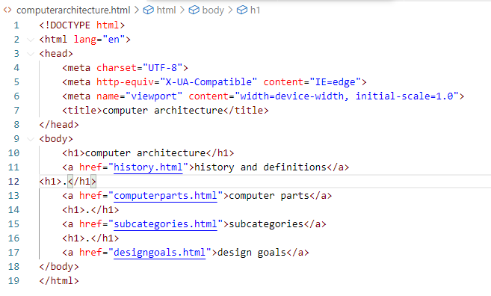*Website source code:

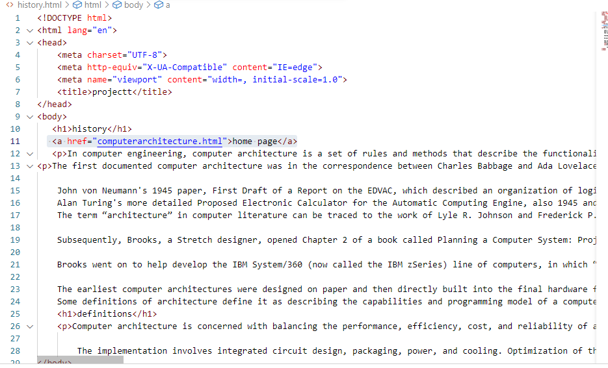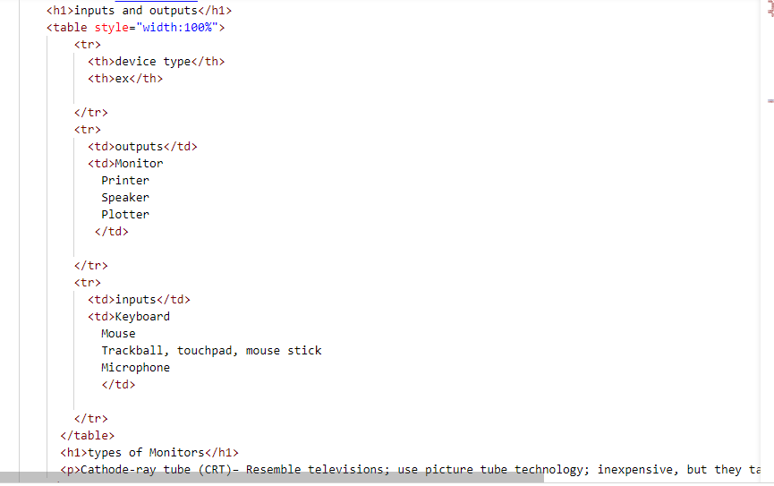

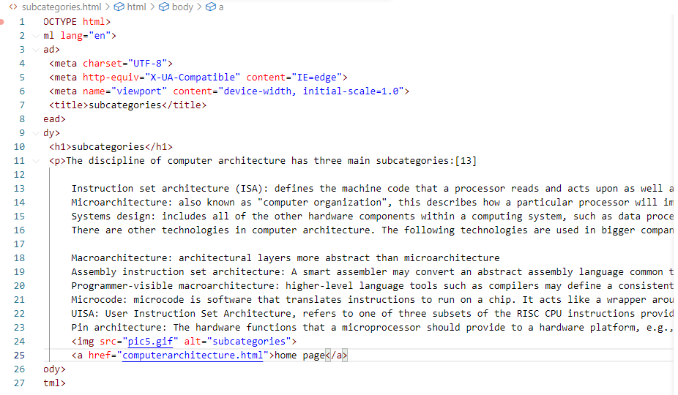

*Thanks for reading 😊